**Ninhydin**

**CAS Number:** 485-47-2

**Molecular Formula:** C9H6O4

**Molecular Weight:** 178.14 g/mol

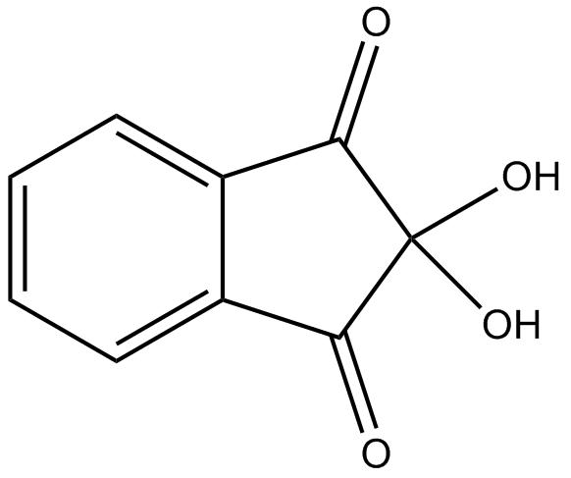

**Appearance** White solid

**Purity (GC)** min. 98.0 %