**ninhydrin**

**CAS Number:** 485-47-2

**Molecular Formula:** C9H6O4

**Molecular Weight:** 178.14 g/mol

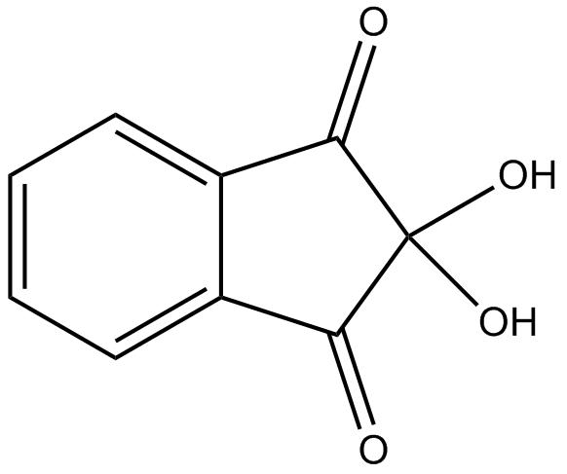

**Solubility:**

**Water** soluble

**Ethanol** soluble

**Chloroform……………………………………..** insoluble