**2-(5-oxo-4-oxa-5-homoadamantan-2-yl)oxy-2-oxoethyl-methacrylate**

**CAS Number:** 1338917-24-0

**Molecular Formula:** C16H20O6

**Molecular Weight:** 308.33 g/mol

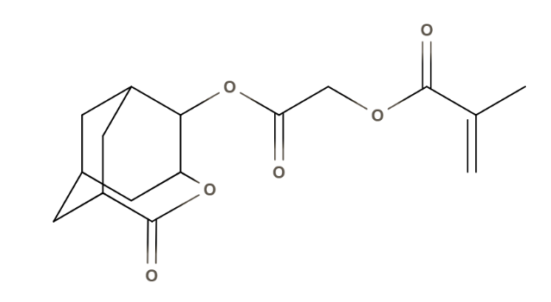

**Solubility:**

**Water** insoluble

**Methanol** insoluble

**Acetonitrile** solubl**e**

**Toluene……………………………………………**soluble