**5-oxo-4-oxa-5-homoadamantan-2-ol**

**CAS Number:** 79499-77-7

**Molecular Formula:** C10H14O3

**Molecular Weight:** 182.22g/mol

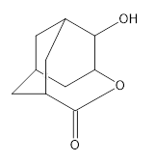

**Solubility:**

**Water** insoluble

**Methanol** soluble

**Acetonitrile** soluble

**Toluene** soluble